/****** Script for SelectTopNRows command from SSMS ******/
SELECT *
FROM [eCoachingUAT].[EC].[Coaching_Log]
Where FormName IN ('eCL-251287-6398121')

Update [eCoachingUAT].[EC].[Coaching_Log]
Set SupID=380484
Where FormName IN ('eCL-251287-6398121')

380484

Update [eCoachingUAT].[EC].[Coaching_Log]
Set EmpID=92895
Where FormName IN ('eCL-251287-6398121')

/****** Script for SelectTopNRows command from SSMS ******/
SELECT*
FROM [eCoachingUAT].[EC].[Employee_Hierarchy]
Where Emp_ID in ('380484','251287','92895','992895')

Update [eCoachingUAT].[EC].[Employee_Hierarchy]
Set Emp_ID =380484
Where Emp_ID IN ('92895')

Update [eCoachingUAT].[EC].[Employee_Hierarchy]
Set Emp_ID =992895
Where Emp_ID IN ('92895')

Update [eCoachingUAT].[EC].[Employee_Hierarchy]
Set Emp_ID =92895
Where Emp_ID IN ('992895')

Update [eCoachingUAT].[EC].[Employee_Hierarchy]
Set Emp_ID =251287
Where Emp_ID IN ('92895')

Update [eCoachingUAT].[EC].[Employee_Hierarchy]
Set Sup_ID =380484
Where Emp_ID IN ('251287')

Update [eCoachingUAT].[EC].[Employee_Hierarchy]
Set Emp_ID =92895
Where Emp_ID IN ('380484')

Update [eCoachingUAT].[EC].[Employee_Hierarchy]
Set Emp_ID =380484
Where Emp_ID IN ('92895')

Update [eCoachingUAT].[EC].[Employee_Hierarchy]
Set Emp_ID =92895
Where Emp_ID IN ('992895')

Update [eCoachingUAT].[EC].[Employee_Hierarchy]
Set Emp_Job_Code =('WACS01')
Where Emp_ID IN ('92895')

WSTE14

CSR
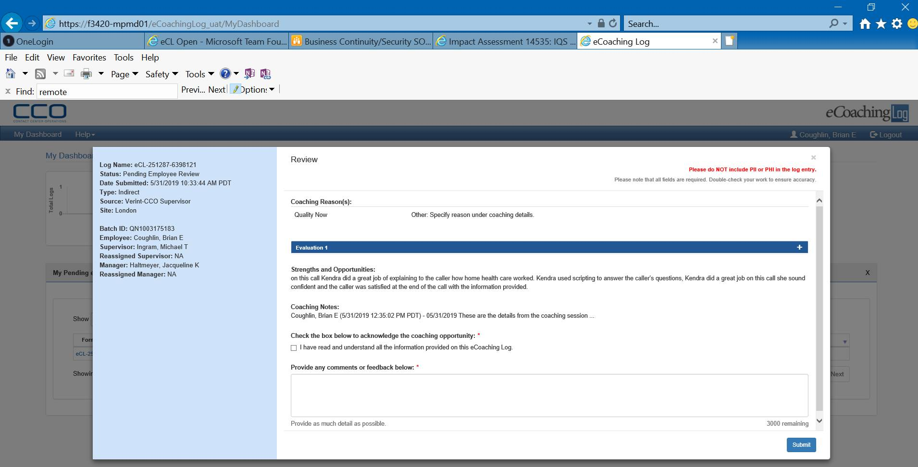
Sup

